Experiment 2

Student Name: Aradhya Sharma UID: 25MCC20042
Branch: MCA (CCD) Section/Group: 25MCC-101A
Semester: 2 Date of Performance: 21 jan 2026

Subject Name: Technical training Subject Code: 25CAP-652

Implementation of SELECT Queries with Filtering, Grouping, and Sorting in PostgreSQL

- AIM:
To implement and analyze SQL SELECT queries using filtering, sorting, grouping, and aggregation concepts in PostgreSQL for efficient data retrieval and analytical reporting.

- OBJECTIVES:
- To retrieve specific data using filtering conditions
- To sort query results using single and multiple attributes
- To perform aggregation using grouping techniques
- To apply conditions on aggregated data

SOFTWARE REQUIREMENTS:
To perform this experiment, the following software is required:
- Operating System
  - Windows 10 / 11, Linux, or macOS
- Database Management System (DBMS)
  - PostgreSQL (version 12 or higher)
- SQL Client / Interface
  - pgAdmin 4 (for PostgreSQL)
OR
  - Command Line Interface (psql)

- PROCEDURE OF EXPERIMENT:

STEP 1: Database and Table Preparation

create table customer_orders(

id serial primary key,

customer_name varchar(20),

product varchar(20),

quantity int,

price numeric(10,2),

order_date date

);

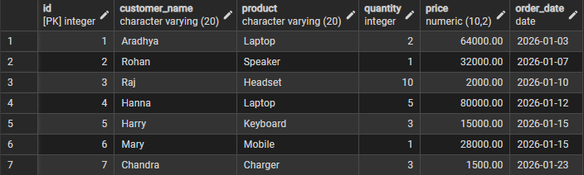
Created a realistic dataset with 10 records suitable for analytical queries.

STEP 2: Filtering Data Using Conditions

select id, customer_name, product, quantity, price

from customer_orders

where price > 30000;

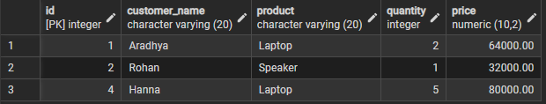

STEP 3: Sorting Query Results

-- Sorting Query Results (Ascending Order)

select id, customer_name, product, quantity, price

from customer_orders

where price > 30000

order by price;

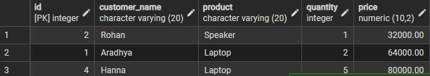

-- Sorting Query Results (Decending Order)

select id, customer_name, product, quantity, price

from customer_orders

where price > 30000

order by price desc;

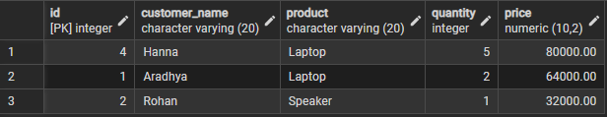

STEP 4: Grouping Data for Aggregation

select product, count(*) as total_sales

from customer_orders

group by product;

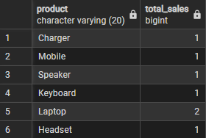

STEP 5: Applying Conditions on Aggregated Data

select product, sum(quantity * price) as total_revenue

from customer_orders

group by product

having sum(quantity * price) > 60000;

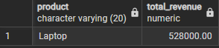

STEP 6: Conceptual Understanding – Filtering VS Aggregation

select product, sum(quantity * price) as total_revenue

from customer_orders

where order_date >= '2026-01-01'

group by product

having sum(quantity * price) > 60000;

- LEARNING OUTCOMES
- Filtering Skills: Learned to retrieve relevant records using the WHERE clause with various conditions.
- Sorting Techniques: Understood ordering results using ORDER BY with single and multiple columns.
- Grouping & Aggregation: Gained proficiency in summarizing data using GROUP BY with aggregate functions such as SUM, AVG, and COUNT.
- Conditional Aggregation: Clearly differentiated between WHERE (row-level filtering) and HAVING (group-level filtering).
- Real-World Application: Built confidence in writing analytical SQL queries used in dashboards and business reports.
- Interview Readiness: Prepared for SQL placement questions on filtering, grouping, aggregation, and analytical functions.

